
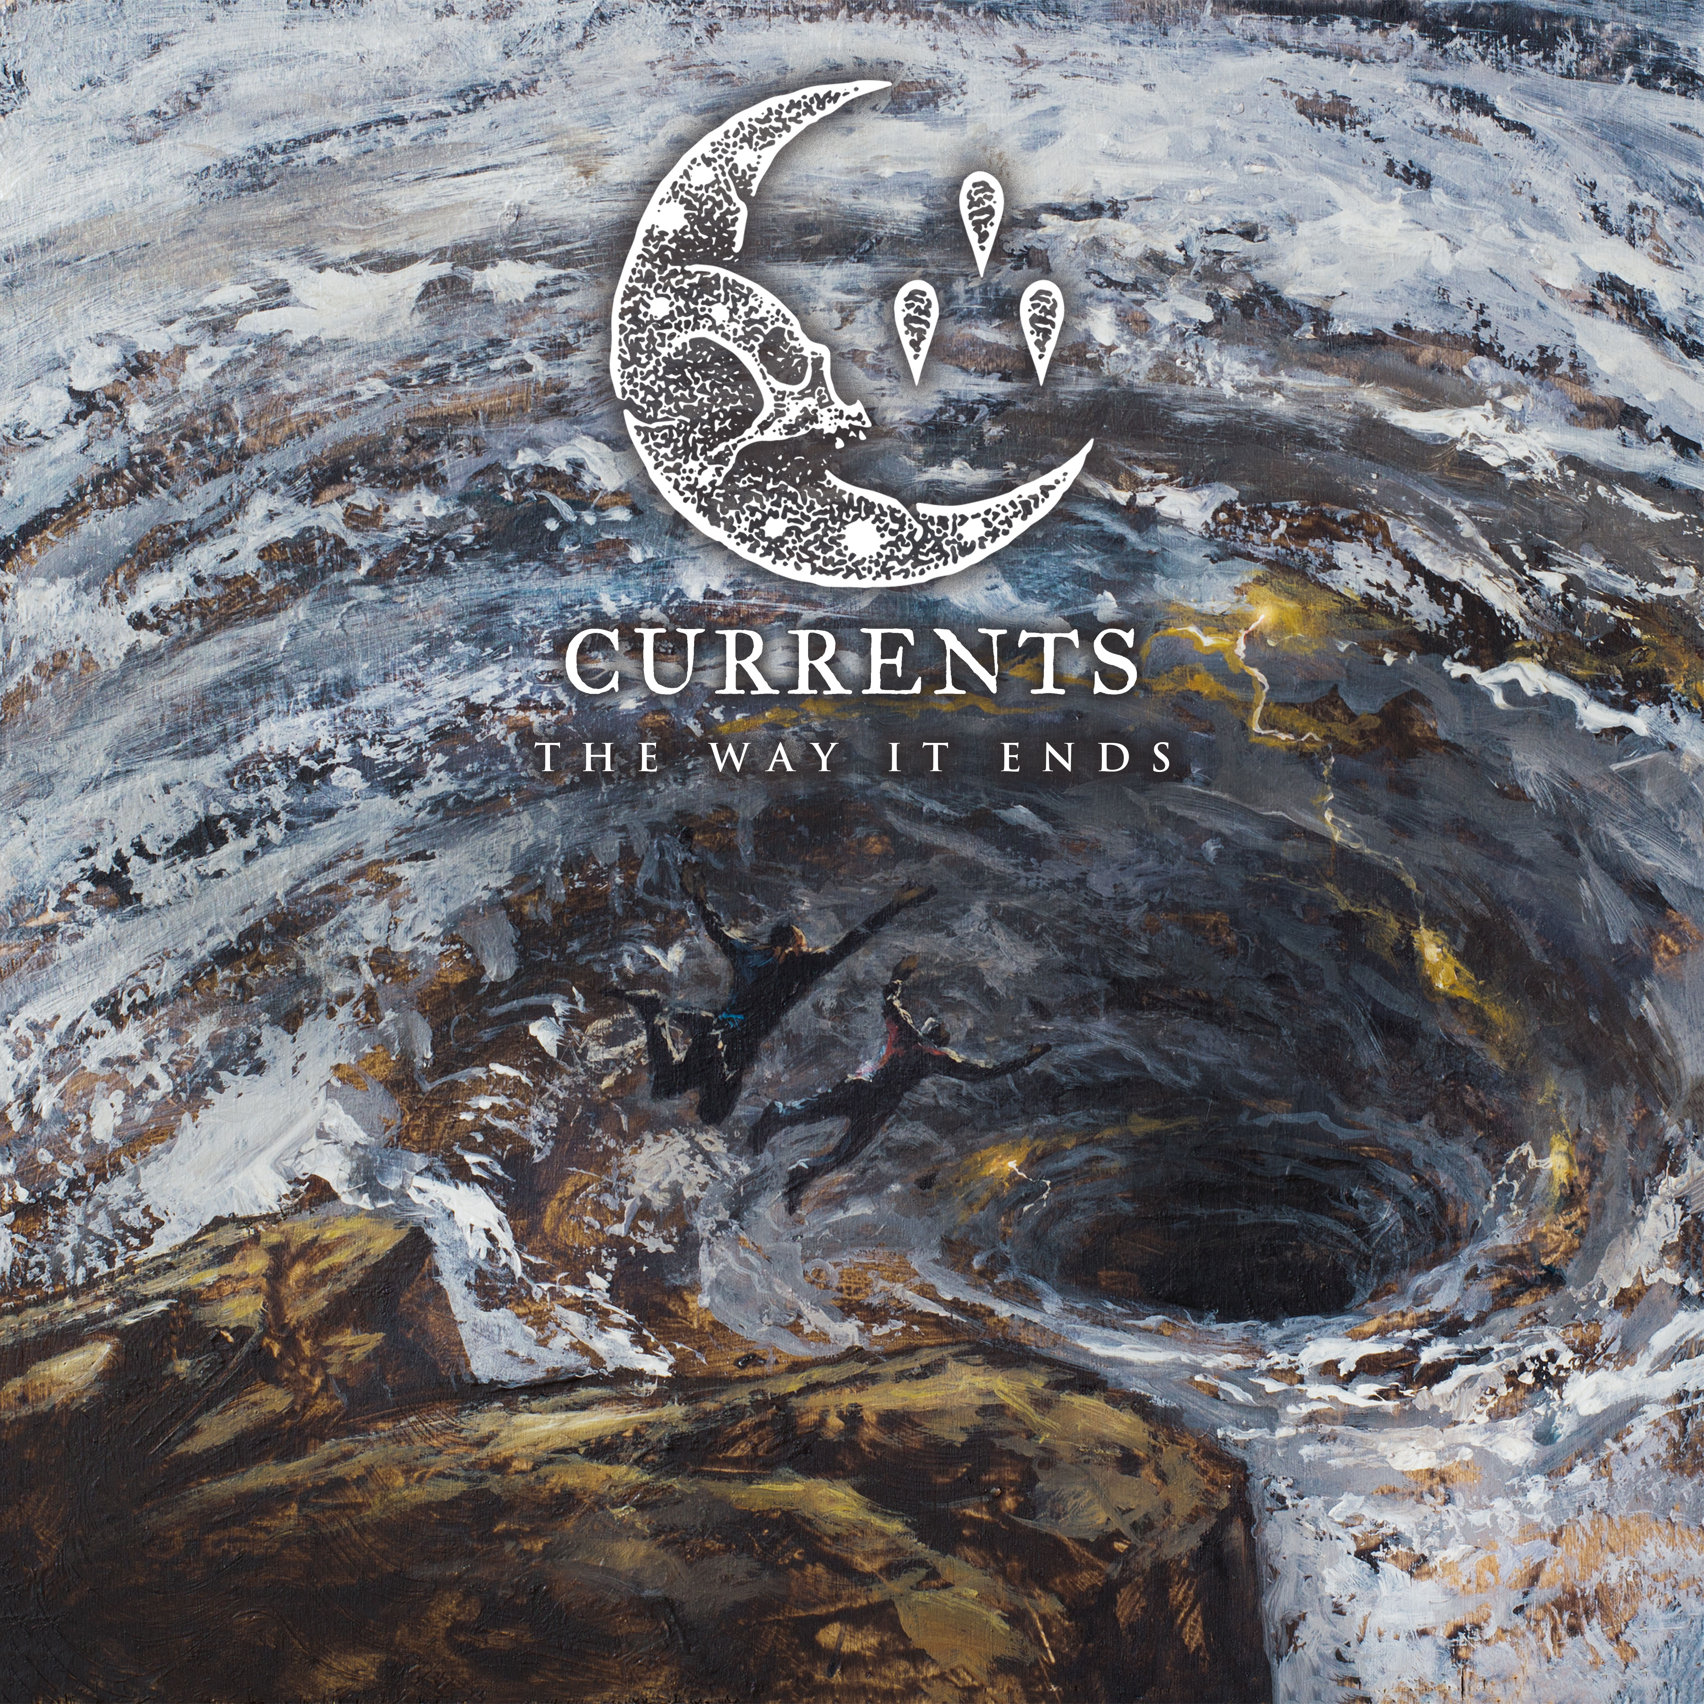

CURRENTS
»The Way It Ends«

OUT: June 5th, 2020

Line up: | CURRENTS online:
Brian Wille | Vocals  Chris Wiseman | Guitar  Ryan Castaldi | Guitar  Chris Pulgarin | Bass  Matt Young | Drums | https://www.facebook.com/CurrentsCT/  https://www.instagram.com/currents  https://twitter.com/currentsct  https://currentsofficial.com/
CURRENTS is the new standard for death-infused metalcore. This is emotionally fraught and impossibly angry music soaked in cold, depressive atmosphere. CURRENTS explore the forbidden realms of a tortured psyche, searching for meaning amidst uncertain chaos and venom.

Heartache, physical abuse, abandonment, trauma – no dark emotion is spared examination. CURRENTS also turn their gaze outward, offering no mercy to man-made catastrophes like climate change and animal abuse. An exploitative system that inflicts such harm upon humanity and the entire world will not be spared the wrath within this explosive, weaponized bombast.

Immediately upon the arrival of the first taste of the band’s second album, the comments section lost its collective mind. Shockingly devoid of the genre’s penchant for hateful trolling, the music video for “Poverty of Self” (a scathing indictment of the predatory industries taking advantage of the sick and broken) was met with an avalanche of praise. “These guys are breakdown scientists,” declared one commenter. “That intro wastes no time to smash you right in the face,” wrote another.

The best gem? “I would donate my organs to this band just to watch them live again.”

“The Way It Ends”, the second full-length from the Connecticut bruisers, is a thematic and spiritual successor to their dense, bludgeoning, and smartly constructed full-length debut, “The Place I Feel Safest” (2017), and a direct follow-up to the blistering and diverse EP, “I Let The Devil In” (2018).

Those well-versed in Meshuggah, Humanity’s Last Breath, Vildhjarta, and Architects have embraced CURRENTS with full-throated passion. A combination of their contemporaries and influences, channeled through unique perspective and personal experience, resulted in something revolutionary. It’s why they were handpicked for tours with August Burns Red, As I Lay Dying, We Came As Romans, Fit For A King, Born Of Osiris, and the Impericon Never Say Die! Tour.

CURRENTS is comprised of singer Brian Wille; guitarists Chris Wiseman and Ryan Castaldi; bassist Chris Pulgarin; and drummer Matt Young. A winding road through earlier incarnations culminated in a series of self-released EPs, leading to the band’s partnership with SharpTone.

Kerrang! put “Silence” from “The Place I Feel Safest” on a list of the 15 Greatest Mosh-Calls in Heavy Music, alongside bangers by genre leaders like Parkway Drive and Code Orange. Calling the song an “exploration of emotional torment, all blunt force riffage, wiry guitars, and spat vocals,” the rock mag summarized the track as “a narcotic blend of melodrama and madness.”

Album number two was produced by ex-For Today guitarist Ryan Leitru (Sleeping Giant, Your Memorial) and Wiseman, generating the kind of expansive and expressive performances best captured by producer/engineers who are also passionate musicians. Mixing duties were handled by ex-Periphery multi-instrumentalist Adam “Nolly” Getgood (Devin Townsend, Animals As Leaders). “The Way It Ends” was mastered by Kris Crummett (Dance Gavin Dance, Issues).

CURRENTS take special care to ensure each release serves a purpose, with a cohesive journey from start to finish, more in line with classic metal albums than today’s mere collections of songs. The lyrics are thoughtful yet accessible, skipping easy t-shirt ready sloganeering for actual depth. Blast beats, breakdowns, and a driving onslaught of riffs are tempered by stripped back, tranquil, ambient moments. There’s post-hardcore, punk rock dissonance, and even black metal esotericism.

“A Flag to Wave” is a CURRENTS anthem, a mission statement kicking “The Way It Ends” off after a moody intro, cascading with devilishly dynamic riffing and intense, rapid fire rhythm. By contrast, album tracks like “Kill the Ache”, “Split” and “Origin” introduce slight electronic elements, keys and synths, that actively drive the songs forward. A significant portion of “The Place I Feel Safest” was about abandonment. Building to a crescendo, “Let Me Leave” serves as a narrative mirror image, from the opposite perspective, a first-person account of the one who walks away.

The raw emotion on display in CURRENTS is the key to the deep connection the band has made with its ever-widening audience. They’ve proven themselves a consistent, determined, and reliable entity that will always challenge themselves and move forward, without compromising their core.

As New Noise declared: “CURRENTS is a band not to be ignored.”

